How to create and share a folder in Google Drive
This Document borrowed from Mr. La Greide at Lincoln High School!

1. Sign into your gmail account, If you don’t have one you can create one.
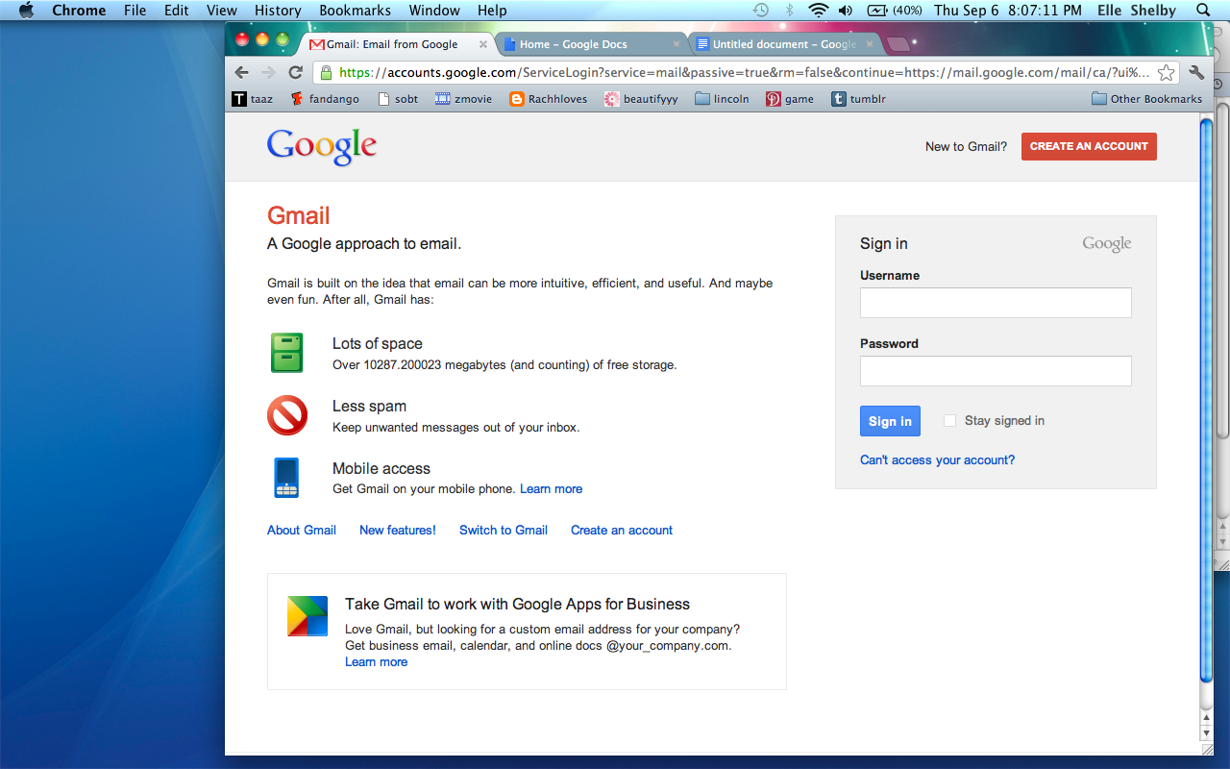
2. Once you have signed in, at the top there is a section called “Drive/Documents” it’s highlighted in this picture. But you click on it.
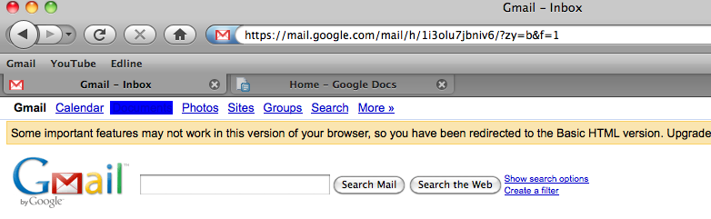

3. When you click it something like this should come up.
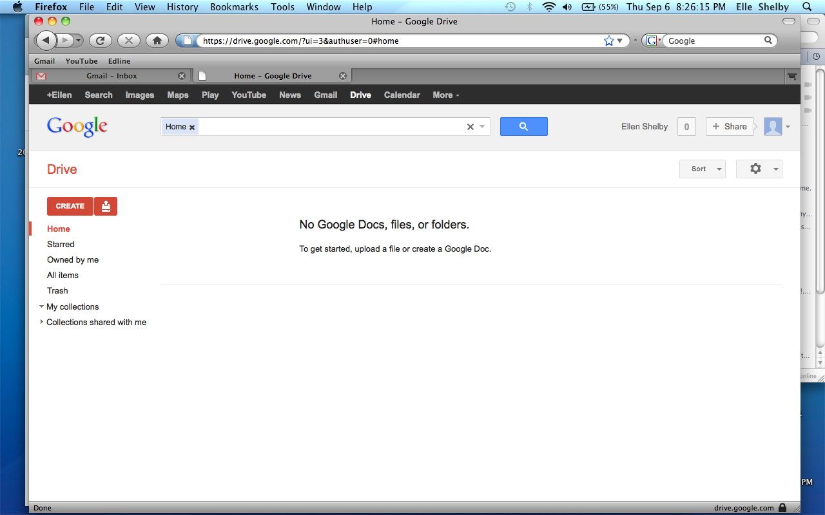
4. Next click on the button “Create” its red. When you click on it go down and click on “Collection
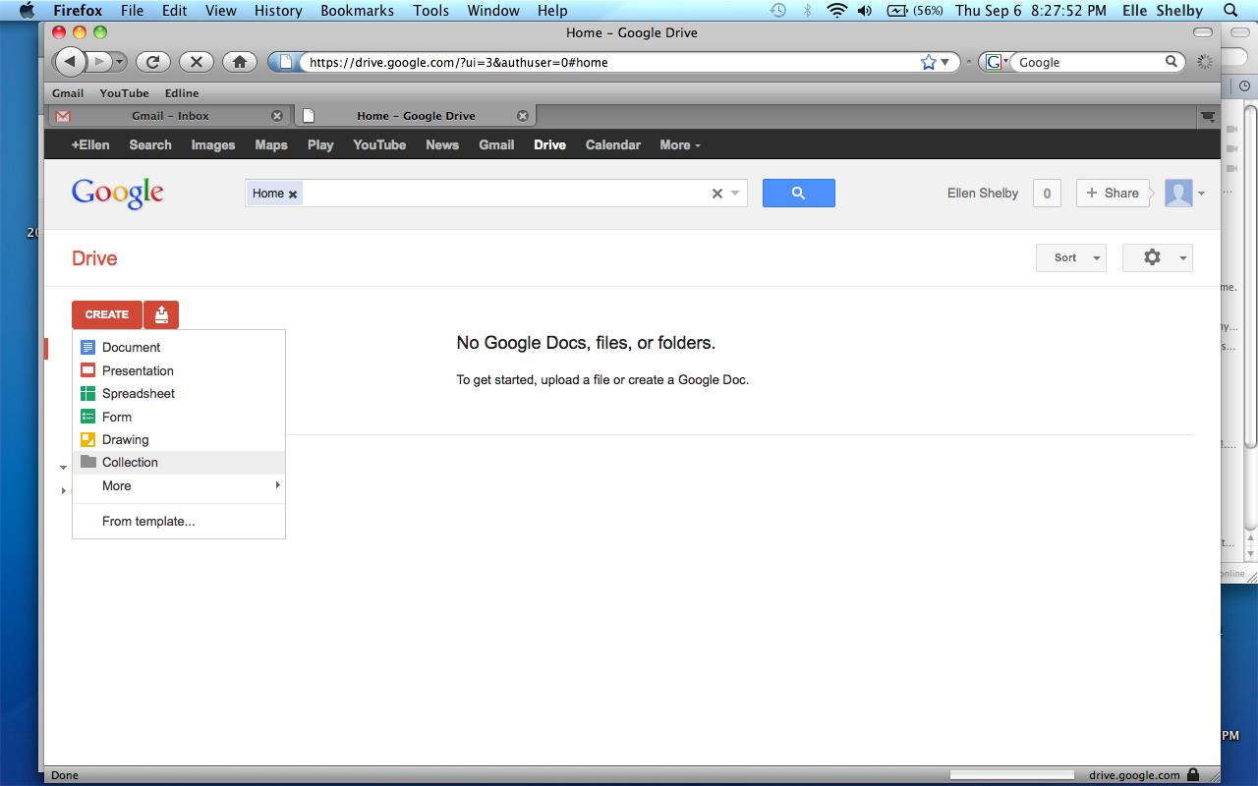

5. This is the next screen that will pop up and type your own name followed by the period you have Meyer laoshi (Example: P8MarieMeyer) and click create.
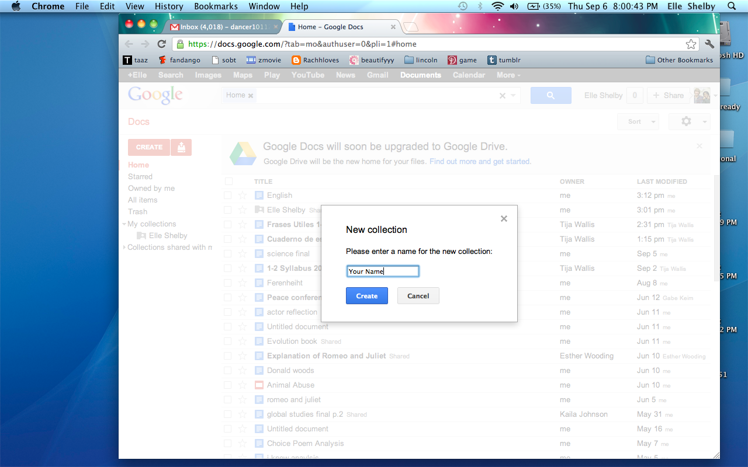

6. You will see the folder with your name appear in the left hand side. When you put the mouse on it you will see an arrow, and it should look like this. Move your mouse to “Share” and then click on the other “Share..” 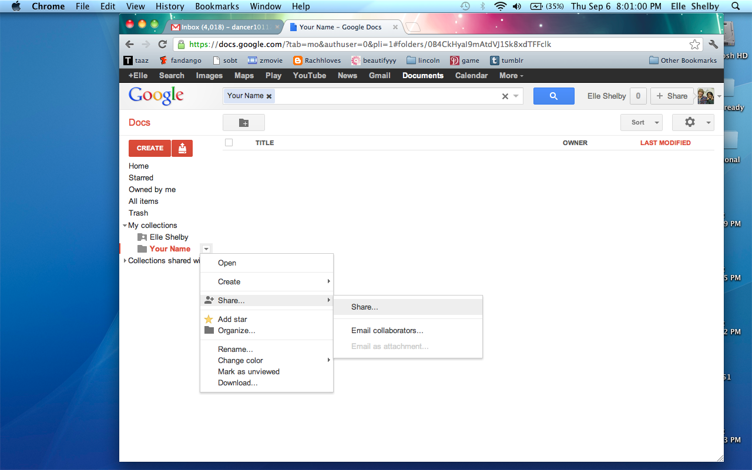
7. Your screen should be like this and at the bottom where it says “Add peope” type in Meyer laoshi’s G-mail address (lhschinese@gmail.com) and press save and share. 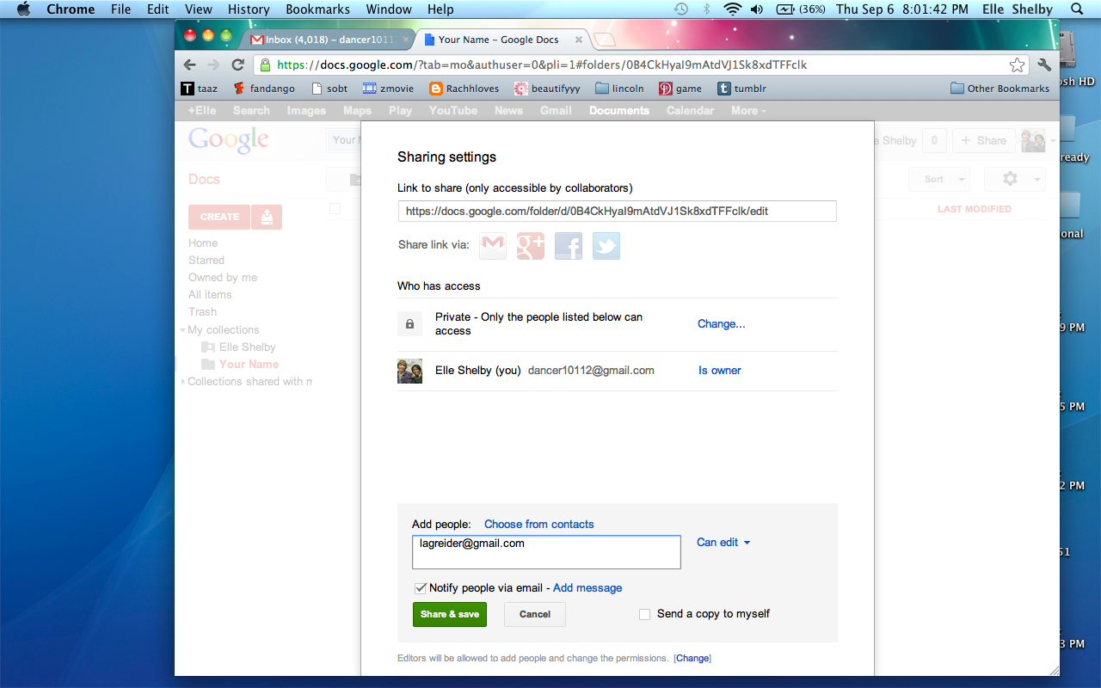
8. That is how you create and share a folder!

